****6.1 Properties and Attributes of Polygons

|  |  |
| --- | --- |
| **Number of Sides** | **Name of Polygon** |
| 3 |  |
| 4 |  |
| 5 |  |
| 6 |  |
| 7 |  |
| 8 |  |
| 9 |  |
| 10 |  |
| 12 |  |
| 15 |  |
| n |  |

What is a polygon?



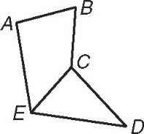Label the picture below using the following:



Side



Vertex



Diagonal



Tell whether each figure is a polygon. If it is a

polygon, name it by the number of its sides.







n = number of sides of the polygon



|  |  |
| --- | --- |
| Regular vs. Irregular | Concave vs. Convex |
|  |  |
|  |  |

Tell whether each figure is regular or irregular.

Tell whether each figure is concave or convex.

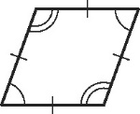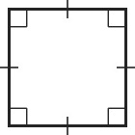

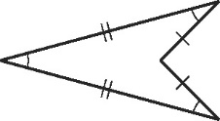  
  
Recall: The sum of the interior angles of a triangle is _______________.



|  |  |  |  |  |
| --- | --- | --- | --- | --- |
| Polygon | # of Sides | Diagram | Number of Triangles  (from one vertex) | Sum of Interior Angle Measures |
| Triangle |  |  |  |  |
| Quadrilateral |  |  |  |  |
| Pentagon |  |  |  |  |
| Hexagon |  |  |  |  |
| n-gon |  |  |  |  |

**Polygon Interior Angle Sum Theorem:**

The sum of the interior angles of a convex polygon with n sides is ________________________.



Examples:

1) Find the sum of the interior angle 2) Find the measure of each interior angle of

measures of a convex pentadecagon. a regular decagon.



3) What is the name of the polygon in 4) What about the exterior angles?

which the sum of the interior angle



98˚

122˚

measures is 1800?



78˚

84˚

72˚



**Polygon Exterior Angle Sum Theorem:**



The sum of the exterior angle measures, one angle at each vertex, of a convex polygon is ________.



5) What is the sum of the exterior 6) What is the measure of each exterior

angles of an octagon? angle of an octagon?



7) An exterior angle measure of a regular polygon is given.

Find the number of sides and the measure of each interior angle.



**Please complete the chart.**

|  |  |  |  |  |  |
| --- | --- | --- | --- | --- | --- |
| Name of Polygon | Number of Sides (n) | Each Exterior Angle | Each Interior Angle | Sum of Ext. Angles | Sum of Interior Angles |
|  |  |  |  |  | 1080 |
|  | 9 |  |  |  |  |
|  |  |  | 108 |  |  |
|  |  | 30 |  |  |  |

1. What is a polygon?

2. Which polygons do you need to study the names of?

3. What is the difference between regular and irregular? Concave and convex?

4. How do you find the sum of the interior angles for a polygon?



5. How do you find the sum of the exterior angles of a polygon?



6. How do you find the measure of one interior angle of a regular polygon?



7. How do you find the measure of one exterior angle of a regular polygon?



8. What is the relationship between an exterior and an interior angle?

