**Unit 3 – Day 21 Homework Name**: ___________________________

1. A line with an undefined slope is (choose one): Horizontal or Vertical ?



**Find the slope of the line given the two points and state what type of line it is (upward, downward, horizontal, or vertical).**

1. (2, 8) and (2, -9) 3. (-3, -7) and (4, -7) 4. (4, -8) and (8, -7)



1. Find the value of *y* so that the line passing through the given points has the given slope.

(-4, y) and (3, 2) ; m = 

**Unit 3 – Day 21 Homework Name**: ___________________________

1. A line with an undefined slope is (choose one): Horizontal or Vertical ?



**Find the slope of the line given the two points and state what type of line it is (upward, downward, horizontal, or vertical).**

1. (2, 8) and (2, -9) 3. (-3, -7) and (4, -7) 4. (4, -8) and (8, -7)



1. Find the value of *y* so that the line passing through the given points has the given slope.



(-4, y) and (3, 2) ; m = 



**Practice graphing the equations on your own!!**

4.) y = 5 5.) x = -3. 6.) y = -2 7.) y = 0

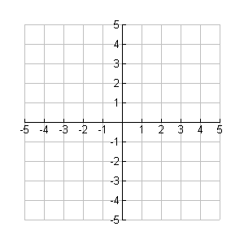



1. Graph y = -2 and x = -2 and list the 9. Graph y = 3 and x = 0 and list the

intersection point. intersection point.







**Practice graphing the equations on your own!!**

4.) y = 5 5.) x = -3. 6.) y = -2 7.) y = 0





1. Graph y = -2 and x = -2 and list the 9. Graph y = 3 and x = 0 and list the

intersection point. intersection point.

