Unit 5 Day 16

Homework

**#1-2) Solve the system of equations by graphing. Determine the number of solutions.**

1. Graph: –x + 4y = -20 2. Graph: y = -2x + 3



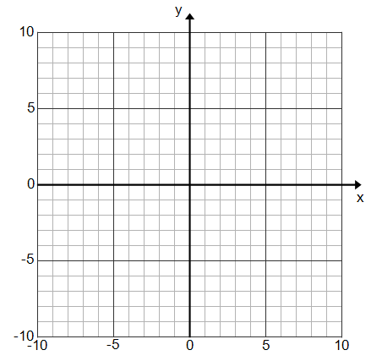 3x – 12y = 48 4y + 8x = 12







**#3-4) Solve the system of equations by substitution/elimination. Determine the number of solutions.**

3. -7x + 7y = 7 4. y = -4 – 2x



2x – 2y = -18 4x – 2y = 8

