Day 13 Notes **Surface Area of Pyramids**

Let’s Recall: In a **regular pyramid**, we know…

* 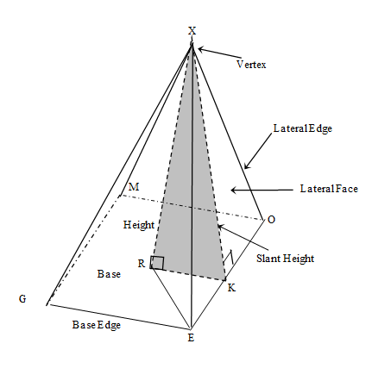







For a regular pyramid…

Lateral Surface Area =

Total Surface Area =



Example 1: Given the square pyramid to the right, find the…



10

12

1. Lateral Area b) Total Surface Area



Example 2: Given a right triangular pyramid with AX = 8 in, BC = 8 in, and AY = 4 $\sqrt{5}$ in, find the…

1. Lateral Area b) Total Surface Area

D

A

B

Y

X

C



Example 3: Given the altitude of a pyramid is 12 cm and the dimensions of the base are 10 cm by 18 cm.

1. Why would the base not be regular?



1. Find the Lateral Area.



1. Find the Total Surface Area.



Example 4: Lilia’s princess playhouse will be in the shape of her favorite solid: a regular square pyramid! The square base has a side length of 8 feet. The height of the playhouse is 3 feet. How much pink paint is needed to cover the outside and floor of her playhouse?



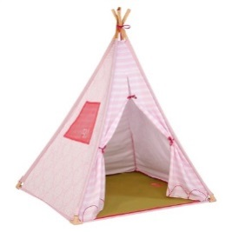



Example 5: You are attending Princess Charlotte’s 1st birthday party and you need to wrap the toy perfectly with wrapping paper. The baby doll toy is packaged in the shape of a regular triangular pyramid. The slant height is 12 inches and the lateral edge is 13 inches. What is the EXACT amount of wrapping paper you will need to cover the entire present (with no overlap)?

