Day 4 – Study Guide – Similarity and Dilations

**9.6 Dilations in the coordinate Plane**

* I can identify and draw translations….. YES or NO?

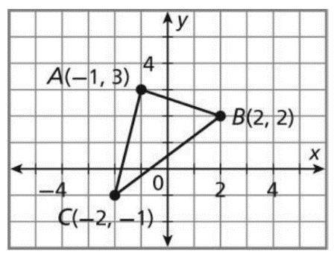**Plot and label the image triangle A’B’C’**

1. Dilate ABC with a scale factor of -1/2 with center (1, 1)

A’(_______, _______) B’(_________, ________) C’(__________, __________)



1. Dilate ABC with a scale factor of 2 with center (2, -1)

A’(_______, _______) B’(_________, ________) C’(__________, __________)

**7.1: Ratios in similar polygons**

* I can identify similar polygons and apply properties of similar polygons to solve problems.
* I can set up and solve proportions!

1. Similar polygons are polygons in which the corresponding sides are __________________________ and the corresponding angles are _________________.

2. Solve each proportion:

a) b) c)

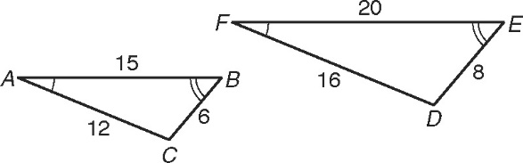

3. Name the congruent angles and corresponding sides.

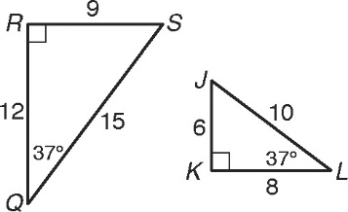

4. **Circle** the correct similarity statement.

QRS  KJL RSQ  KJL QSR  LKJ

5. Give the similarity ratio and write a similarity statement.

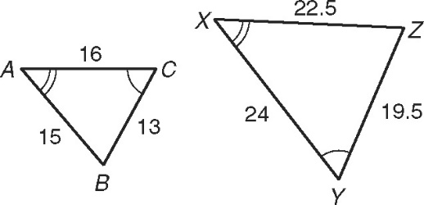

Ratio: ____________

Similarity Statement: ______________________

6. Given: JLM ~ QST

J

L

M

3y – 2

4

6x – 3

T

S

Q

3

2

58

70

60

a) Find x, y, and m∠T.

1. What is the ratio of the sides?

**Applications:**

7. Leonardo da Vinci’s famous portrait the Mona Lisa is 30 in. long and 21 in. wide. Miss Palumbo went to Paris and got a magnet of the painting that is 3.5 cm wide. What is the length of the magnet?

8. Mrs. Klotz wants to hang a poster in her dining room of her and her adorable daughters. The original photograph is 4in. by 6in. The poster will be 21 ft. by 31.5 ft. What is the scale factor of the enlargement?

**7.3: Triangle Similarity: AA~, SSS~, and SAS~**

* I can prove certain triangles are similar by using AA~, SSS~, and SAS~
* I can use triangle similarity to solve problems.

1. Explain why the triangles are similar and write a similarity statement. **Show the sides are proportional if necessary.**



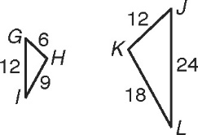

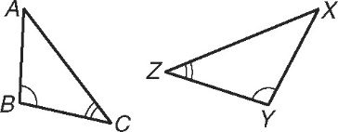a.) b.)

Reason: ____________ Reason: ____________

Similarity Statement:________________ Similarity Statement:________________

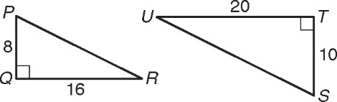c.) Reason: ____________

Similarity Statement:________________

2. Determine if the following polygons are similar. If they are, state the reason and complete the similarity statement.

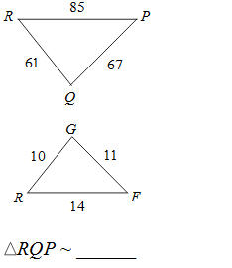

1. 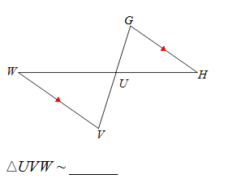 b.) c.)

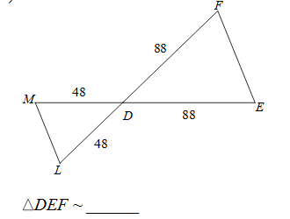

Reason: Reason: Reason:

3. The triangles in each pair are similar. Solve for x.

a.) JKL ~ JSR b.) KLM ~ KST

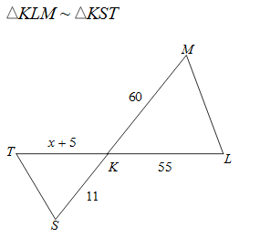

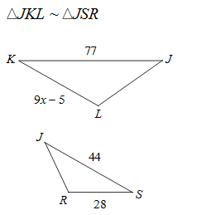

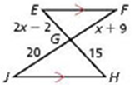c.) PRQ ~ PTS d.) EGF ~ HGJ

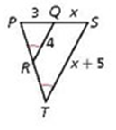

**Self Reflect:** What section was the easiest for you? ________________ Most challenging?____________________

What are you going to do to study for the quiz?!______________________________