Day 12 3.7 Lines in the Coordinate Plane

Target: Graph lines and write equations in slope-intercept form and point-slope form

Warm up: **Find the slope of each line that passes through the points. Identify the type of line.**

1) (5, 2) and ( 4, -1) 2) (-2, 3) and (4, 6) 3) 



New Stuff:



**Slope-Intercept Form:**

Given Slope and a Point on the line, write the equation in Slope - Intercept Form and Point-Slope Form

**Slope - Intercept Form Point-Slope Form**



Ex 1: m = -3 and (2, 4)



Ex 2: m = 2 and (-3, -5)



**Given two points on the line, write the equation in Slope - Intercept Form and Point-Slope Form**

**Slope - Intercept Form Point-Slope Form**

Ex 3: (4, 2) and (-4, -6)



Ex 4: (2, -6) and (-3, 4)



Ex 5: Write the equation of a line with an x-intercept of 4 and a y-intercept of 3. Write the equation in slope-intercept form and point-slope form.



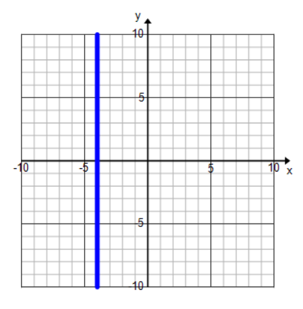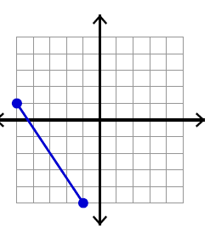**Write the equation of the line given the graph.**

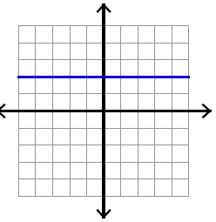

6. 7. 8.



_______________________ _______________________ _______________________



Horizontal / Vertical Lines

* A horizontal line will have a slope that is ____________ and the equation of the line will be __________
* A vertical line will have a slope that is _______________ and the equation of the line will be __________