Day 18 Notes **Volume of Pyramids & Cones**

**Volume of Volume of**

**a Pyramid a Cone**

1) Find the volume of the cone. 2) Find the volume of the regular



14

24

(The picture is not drawn to scale!) hexagonal pyramid.

16

120º

3) A water cup at the local gym is the shape of a cone. The diameter is 5cm and the height is double the

diameter. How many square centimeters, to the nearest hundredth, of water can the cone cup hold?

4) Find the volume of the regular based pyramid. 5) Find the volume of the cone.



12

10

20

24

What do you think happens to the volume of the What do you think happens to the

pyramid when the… volume of the cone when the…

1. height is tripled? a) height is multiplied by ½?
2. base is tripled? b) radius is multiplied by ½?
3. height and base are tripled? c) height and radius are multiplied by ½?

6) Find the volume of a cone with a base circumference of 25 and a height 2 inches more than twice the radius.

**Partner Practice!** Find the volume of the following solids. Leave answers exact (in terms of π)!

1. 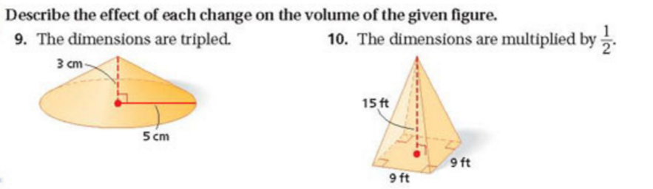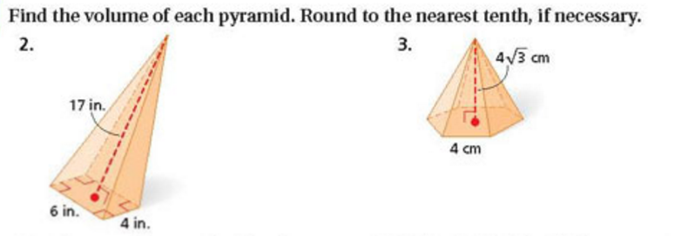 2.

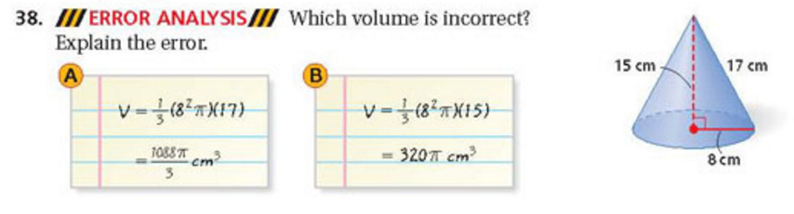

1. 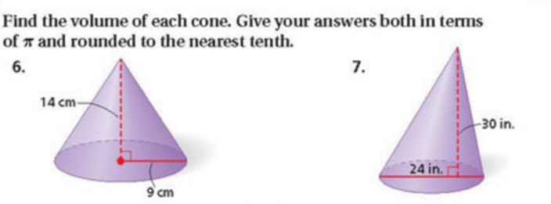 4.

5. Find the volume of a cone with a base area 36πft2 and a height equal to twice the radius.

6. Find the volume of a cone with slant height 10 feet and height 8 feet.