C:\Users\kmounger\AppData\Local\Microsoft\Windows\Temporary Internet Files\Content.IE5\N0987YUH\MC900389758[1].wmf3.2 Angles Formed by Parallel Lines and Transversals

Today’s Target: Use theorems about the angles formed by parallel lines and a transversal

**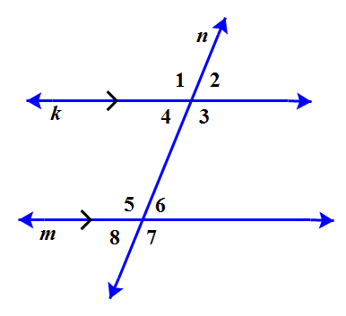**Part 1: In the diagram below, line *m* is **parallel** to line *k*. If the, find all of the missing angles



Part 2: Using the 3.1, 3.2 Lab and the diagram above, please fill in each of the postulates or theorems.

|  |  |  |
| --- | --- | --- |
| Postulate/Theorem | Hypothesis | Conclusion |
| Corresponding Angles Postulate:  If two parallel lines are cut by a transversal, then the pairs of | 2  3  6  7 |  |
| Alternate Interior Angles Theorem:  If two parallel lines are cut by a transversal, then the pairs of | Go07an_0302rete_08 |  |
| Alternate Exterior Angles Theorem:  If two parallel lines are cut by a transversal, then the pairs of | Go07an_0302rete_09 |  |
| Same Side Interior Angles Theorem:  If two parallel lines are cut by a transversal, then the pairs of | Go07an_0302rete_08 |  |
| Same Side Exterior Angles Theorem:  If two parallel lines are cut by a transversal, then the pairs of | Go07an_0302rete_09 |  |

Geometry meets Algebra!

Part 3: State the theorem or postulate that is related to the measure of the angle pairs.

Then, find each angle measure.



1) \_\_\_\_\_\_\_\_\_\_\_\_\_\_\_\_\_\_\_\_\_\_\_\_\_\_\_\_ 2) \_\_\_\_\_\_\_\_\_\_\_\_\_\_\_\_\_\_\_\_\_\_\_\_\_\_ 3) \_\_\_\_\_\_\_\_\_\_\_\_\_\_\_\_\_\_\_\_\_\_\_\_\_\_\_



m1 = \_\_\_\_\_\_\_\_\_\_\_\_\_\_\_\_\_\_\_\_ x = \_\_\_\_\_\_\_\_\_\_\_\_\_\_\_\_\_\_\_\_\_\_ m4=\_\_\_\_\_\_\_\_\_\_\_\_\_\_\_\_\_\_



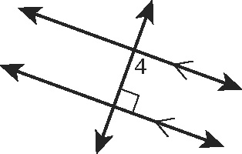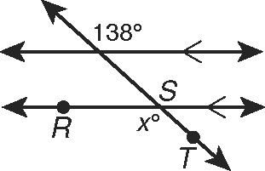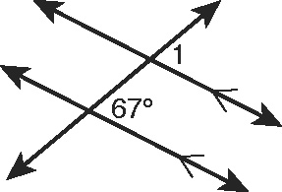



4) \_\_\_\_\_\_\_\_\_\_\_\_\_\_\_\_\_\_\_\_\_\_\_\_\_\_\_\_ 5) \_\_\_\_\_\_\_\_\_\_\_\_\_\_\_\_\_\_\_\_\_\_\_\_\_\_ 6) \_\_\_\_\_\_\_\_\_\_\_\_\_\_\_\_\_\_\_\_\_\_\_\_\_\_\_



mLMN = \_\_\_\_\_\_\_\_\_ mWXZ = \_\_\_\_\_\_\_\_\_ mABC = \_\_\_\_\_\_\_\_\_



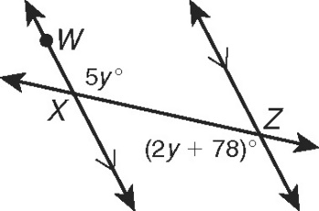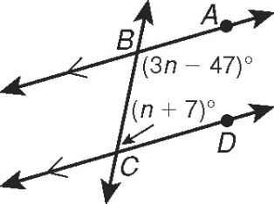 mMPQ = \_\_\_\_\_\_\_\_\_ mBCD = \_\_\_\_\_\_\_\_\_



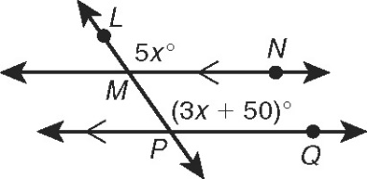



7) \_\_\_\_\_\_\_\_\_\_\_\_\_\_\_\_\_\_\_\_\_\_\_\_\_\_\_\_ 8) \_\_\_\_\_\_\_\_\_\_\_\_\_\_\_\_\_\_\_\_\_\_\_\_\_\_ 9) \_\_\_\_\_\_\_\_\_\_\_\_\_\_\_\_\_\_\_\_\_\_\_\_\_\_\_



mMNP = \_\_\_\_\_\_\_\_\_\_\_\_\_ x = \_\_\_\_\_\_\_\_\_\_\_\_\_\_\_\_\_\_\_\_\_\_ x = \_\_\_\_\_\_\_\_\_\_\_ y = \_\_\_\_\_\_\_\_\_\_\_



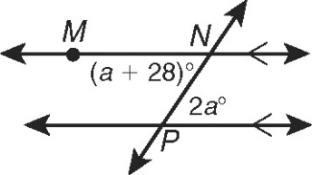

x2 -9x

-3x + 20

a

b

x + 3y

a

b



5y + 20

2x + 30

