A student who waits on tables at a restaurant recorded the cost of meals (meal tab) and the tip left by single diners.

MC900383350[1]

|  |  |  |  |  |  |
| --- | --- | --- | --- | --- | --- |
| **Meal Cost** | $4.75 | *$6.84* | $12.52 | *$20.42* | $8.97 |
| **Tip** | $0.50 | *$0.90* | $1.50 | *$3.00* | $1.00 |

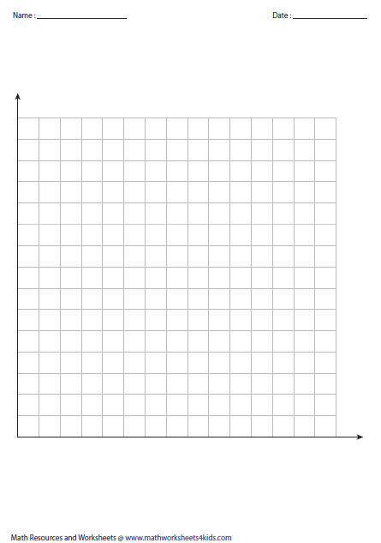

a) Identify the independent and dependent variables.



Independent: _________________________________



Dependent: ___________________________________



b) Label your axes, create a scale and make a scatter plot.



c) Describe the correlation of the data:



_________________________________________________________



__________________________________________________________



d) Using the points italicized in the table above, write the equation of a line of fit in slope-intercept form.



e) Explain the meaning of the y-intercept. f) Explain the meaning of the slope.



g) Predict a reasonable tip this waiter would receive on a $15 tab.



h) If this waiter received a $3.25 tip, what is a reasonable meal cost that the customers accrued?



i) ***Challenge!*** Use your model to predict a reasonable tip on a $20 meal. If the tax collected on the meal cost is 9% (pre-tip), how much would a customer pay in total?

