LEVEL ONE

1. Is the point (-5, 2) a solution to the system: 2. Solve the system by GRAPHING

-5x – 2y = 21 y = $\frac{1}{3}x$– 3



-x + 2y = 8 y = -x + 1



1. Solve the system using SUBSTITUTION. 4. Solve the system using ELIMINATION.

2x + y = 20 -x – 7y = 14



6x – 5y = 12 -4x – 14y = 28



LEVEL TWO

You decide to buy flowers for your mom. ☺ She loves Lilies and Tulips. You purchase Lilies for $3.00 a flower and Tulips for $2.00 a flower. Your total comes to $27.00. You buy a total of 11 flowers. How many of each flower did you buy?

**Define the Variables: System of Equations: Solution:**



LEVEL THREE

Use a graphing calculator to solve the system of equations below.

1. y – 3.2x = 5.6 B) 3x – 5y = 35



y = -4.5x – 10.2 - y = $\frac{3}{4}x- 15$



LEVEL FOUR

**Graph the following systems of inequalities.**

y > -2 x – y > 7



2x + y ≤ 4 y < -2x + 8



LEVEL FIVE

**Given the graph, write the equation of the other system of linear inequalities.**

1. 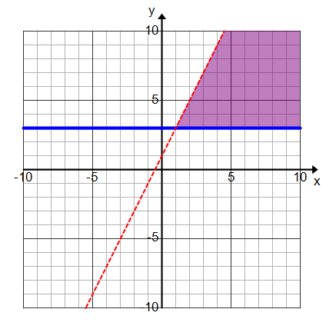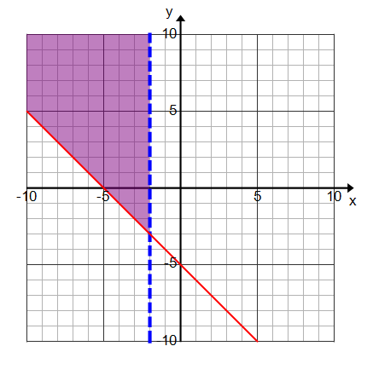 B)



LEVEL SIX

**Graph the following systems of inequalities and find the points of the feasible region.**

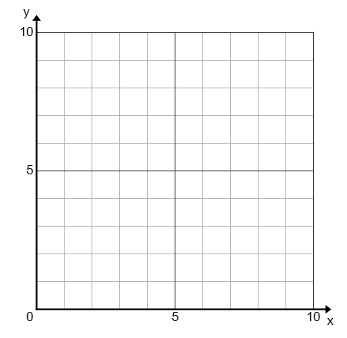x ≥ 0

y ≥ 0

5y ≤ -x + 10



y ≤ - x + 6



LEVEL SEVEN

**During the summer, you want to earn at least $48 per week. You earn $8 per hour babysitting (x) and you earn $6 per hour working at Trader Joe’s (y). You can work at most 25 hours per week.**

a)Write and graph a system of linear inequalities

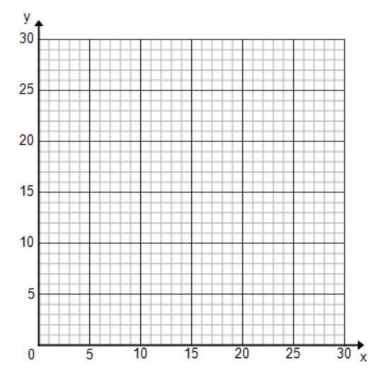

# of hours babysitting

# of hours

working at

Trader Joes



b) Graph the inequalities



c) Points of the feasible region



1. What is the maximum of hours you babysit?



1. What is the maximum of hours your work at Trader Joes?

